1. Create one IAM user and assign ec2,s3 full access role

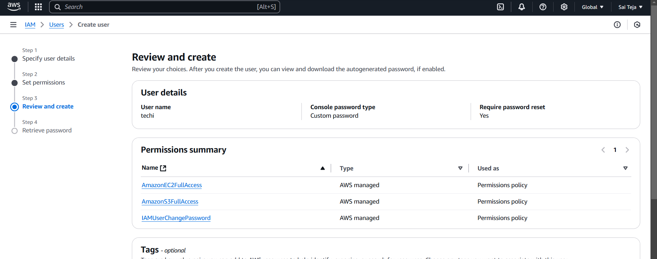

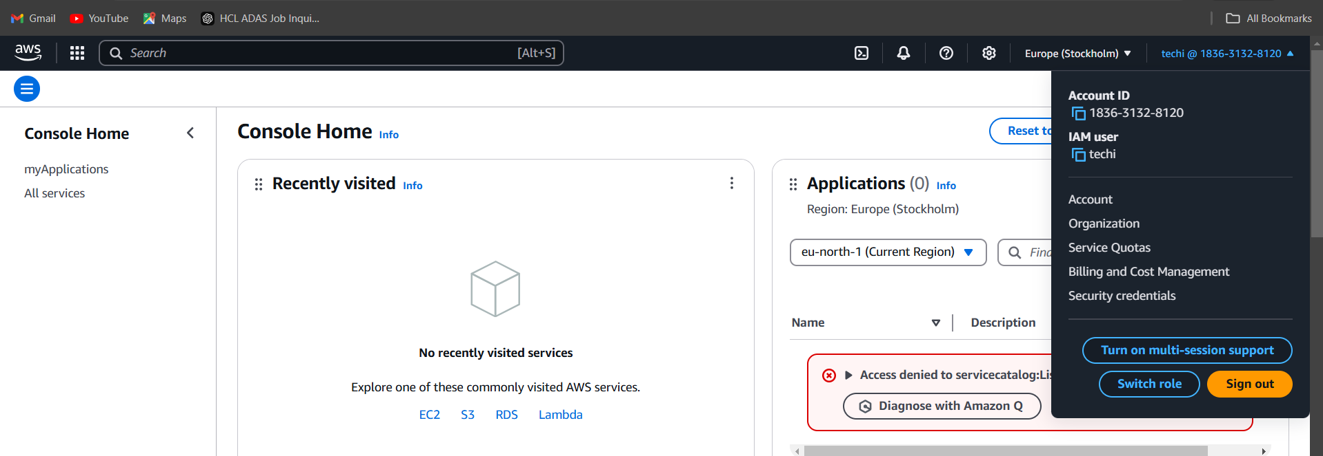

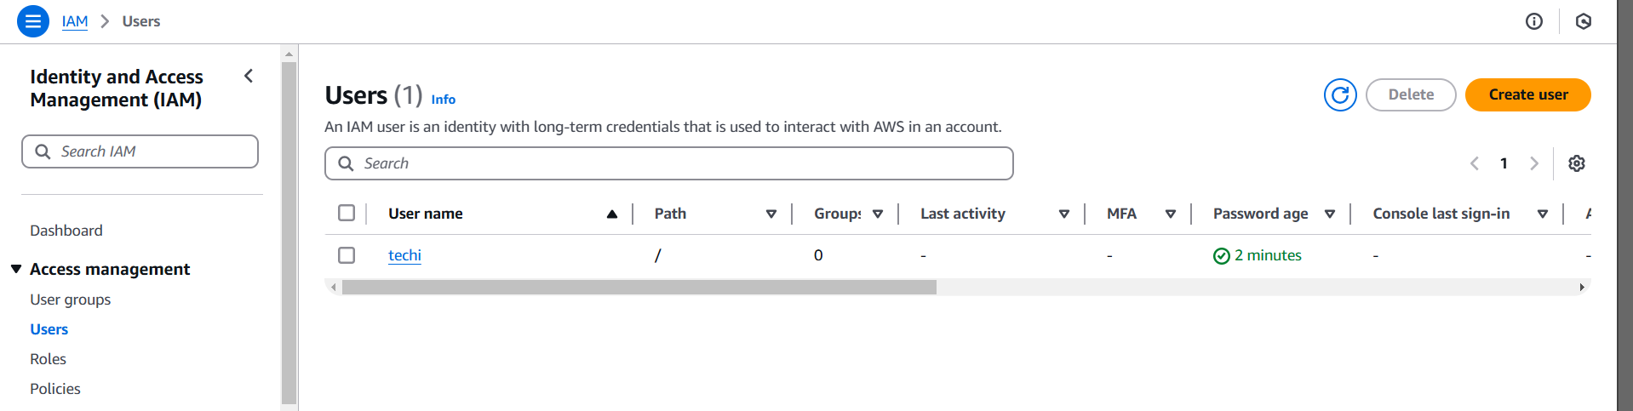

1. Create one Group in IAM and Assign Read access for ec2.

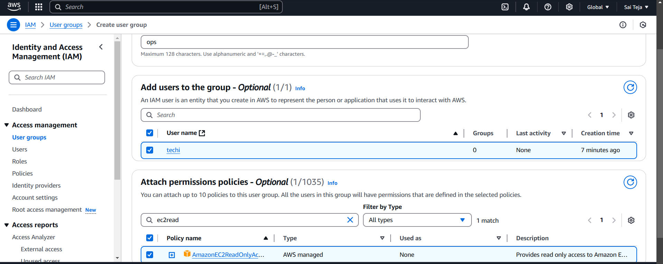

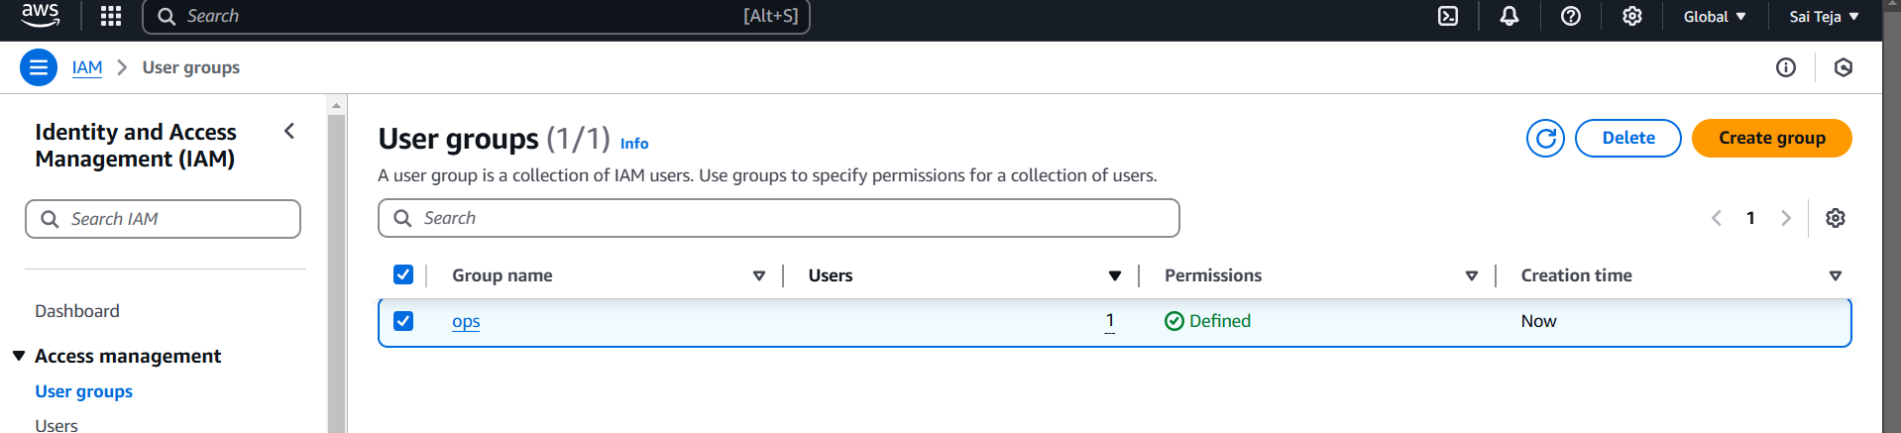

1. Create a new user with name Devops and add to the group created in task2.

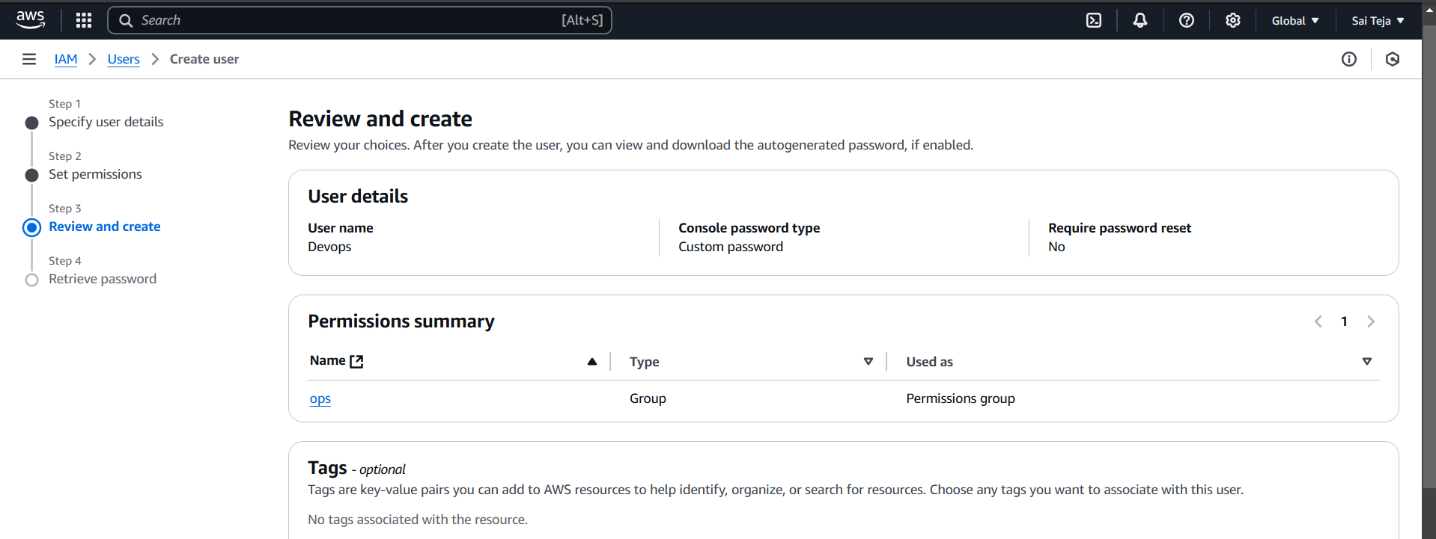

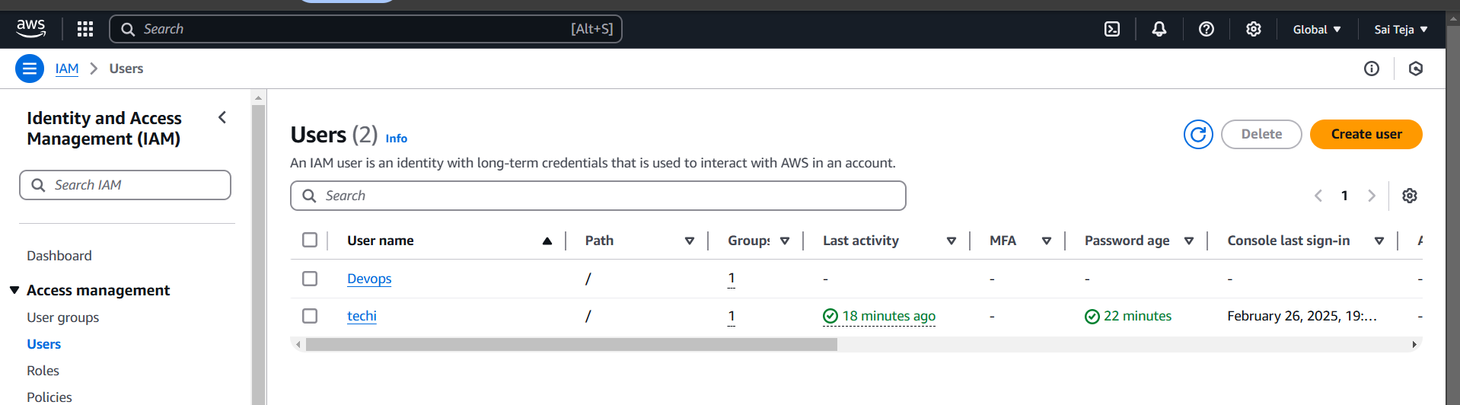

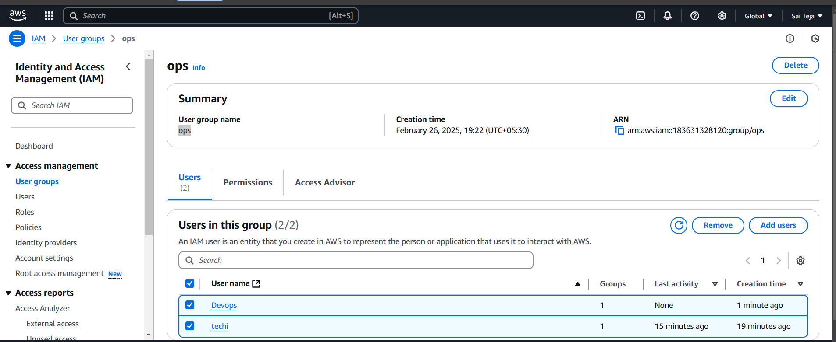

1. Write a bash script to create a IAM user with VPC full access.

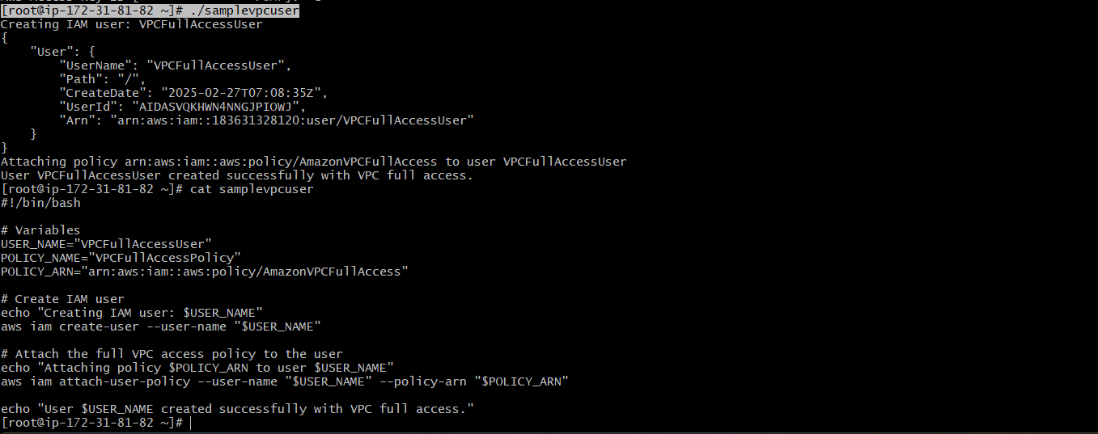

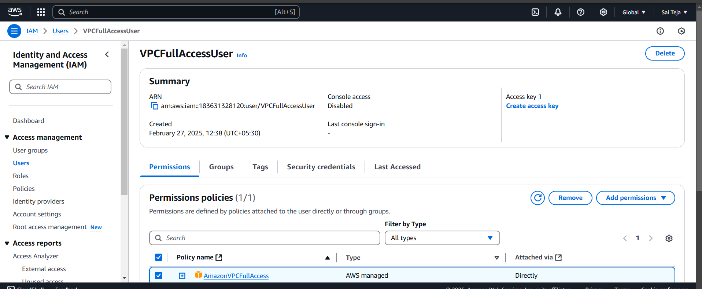

5) Create a IAM policy to access ec2 for a specific user in specific regions only.

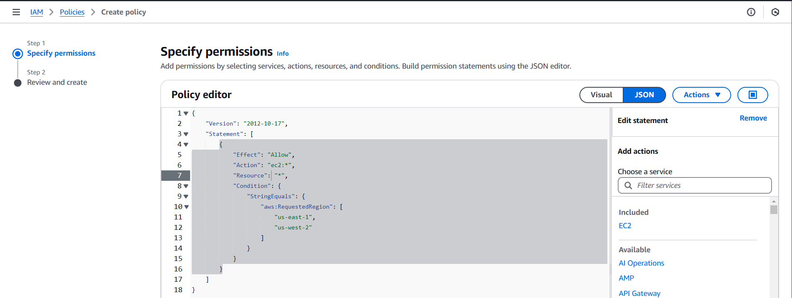

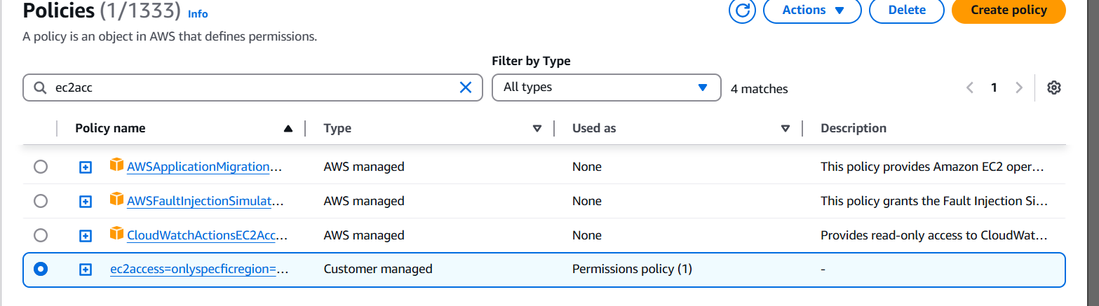

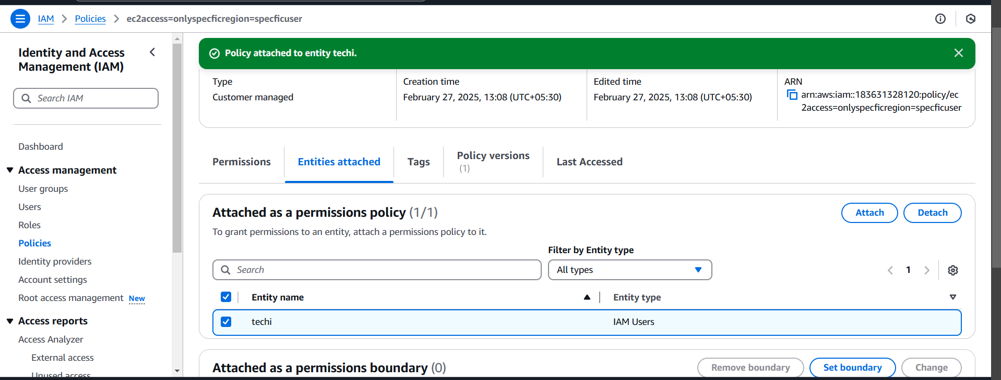

**6) We have two accounts Account A and Account B, Account A user should access s3 bucket in Account B.**

* Created a s3 bucket from my account (Account B)

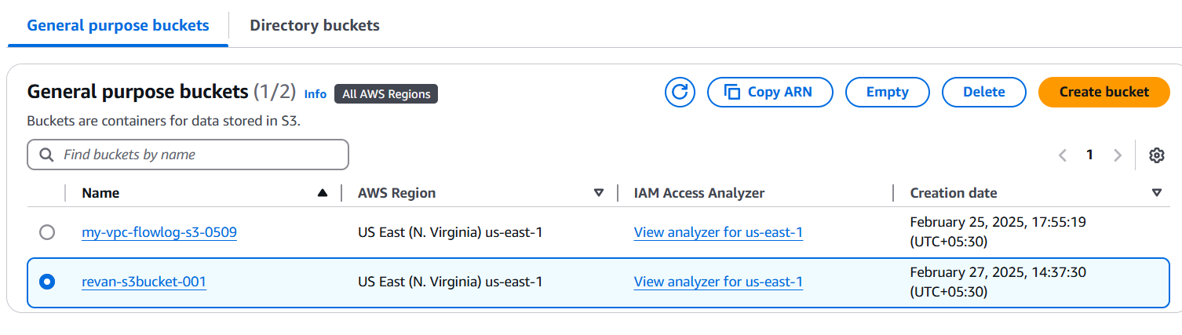

* Attached a json policy to the s3 bucket, adding account A id

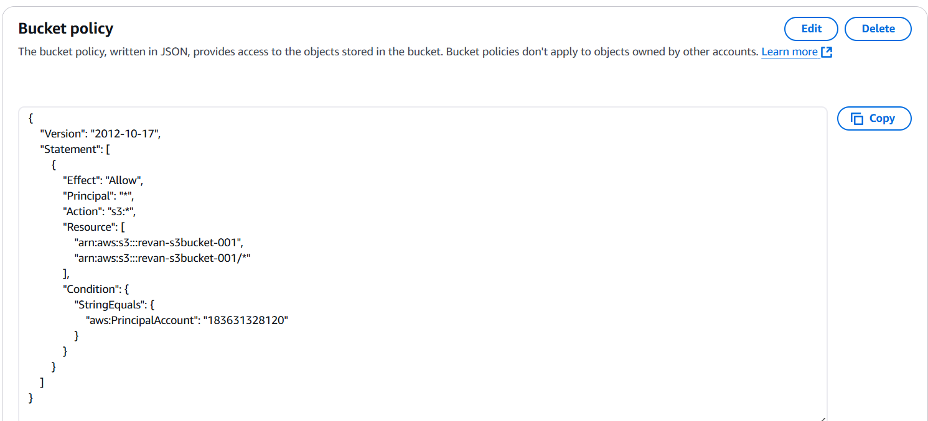

* Created a s3 bucket access policy from account A

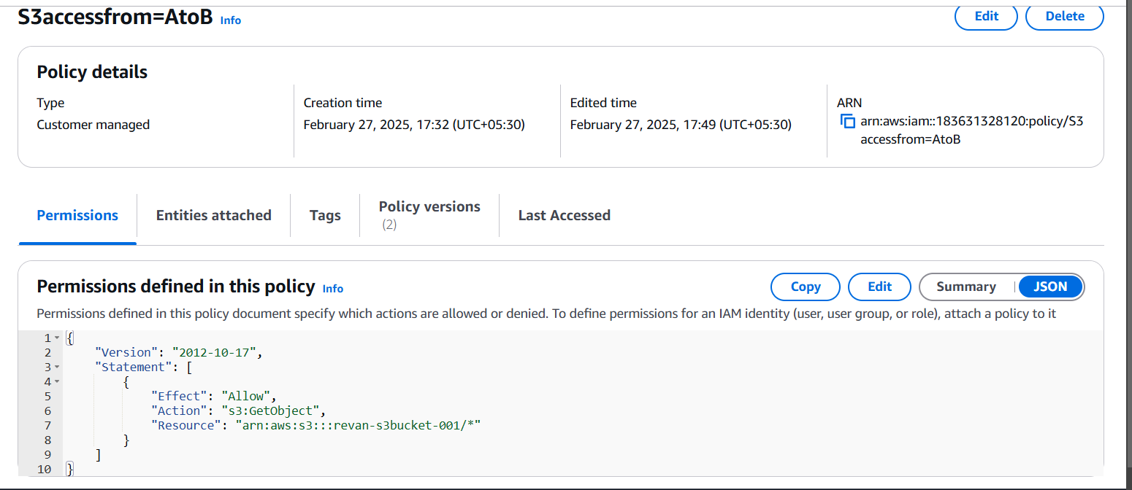

* Attached an IAM user (techi) to this policy ( from account A)

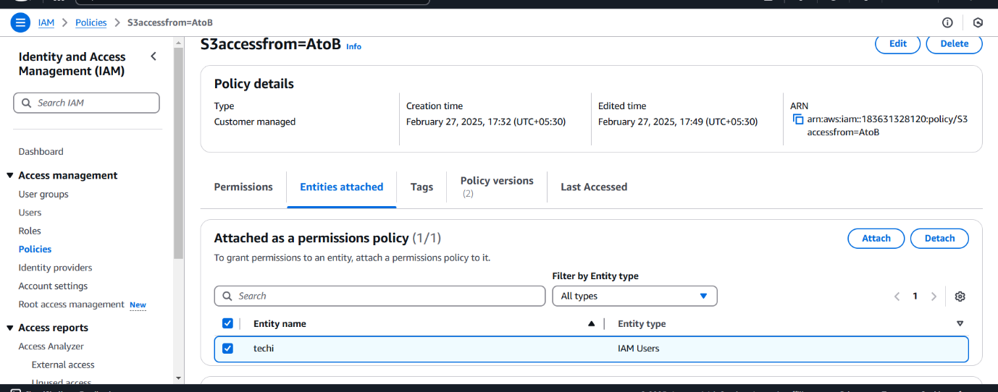

* Configured Account A account using aws cli

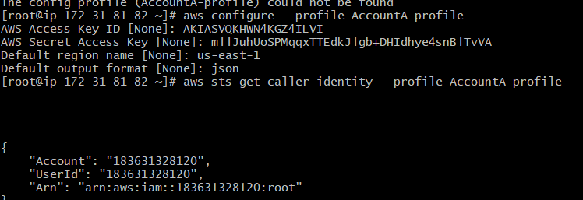

* s3 bucket objects in account B

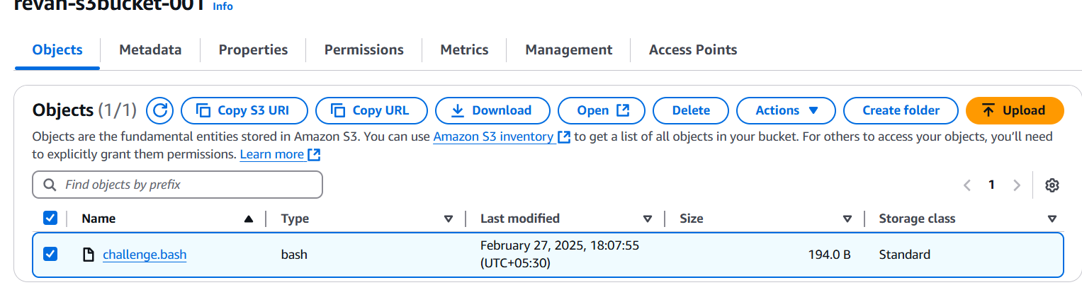

* Account A was able to access the s3 bucket objects of account B, using below command:

